Instituto Tecnológico de Tijuana

Tecnológico Nacional de México

Subdirección Académica

Departamento de Sistemas Computacionales

Agosto – diciembre 2020

Datos Masivos

Unidad I

Practica de Git Flow

Manzano Guzmán Jesua 16212033

Romero Hernández José Christian

18 de septiembre de 2020

The first thing we must do is clone the repository with the command:

*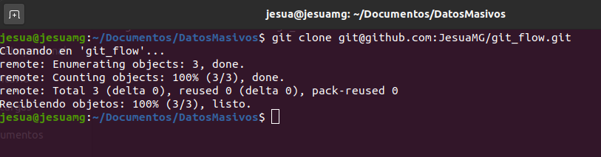git clone git@github.com:JesuaMG/git_flow.git*

The readme.md file was modified, so for the changes to be reflected we have to enter the following commands:

*git add .*

To add the modified file.

Then the command git commit -m "README.md from the master branch" this will be the message that will be displayed in the repository of the modification we made and to finish git push to update the files in the repository.

To create a new branch called Development we must write the following command:

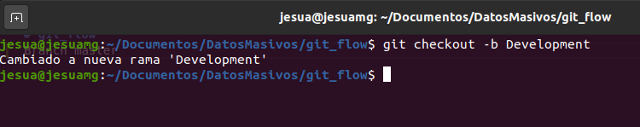*git checkout -b Development*

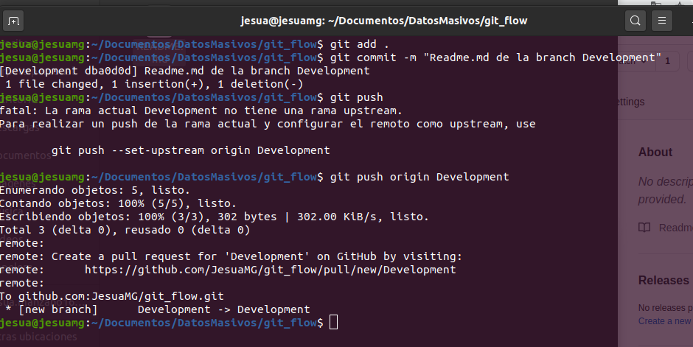

In this case the readme.md file was modified again but now from the Development branch

And the whole process was repeated for the Features branch.

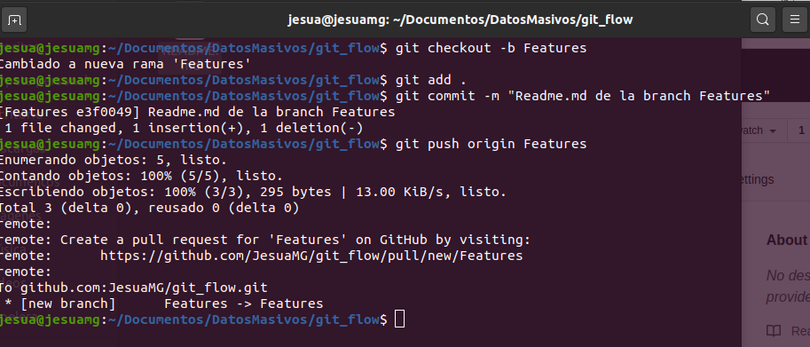

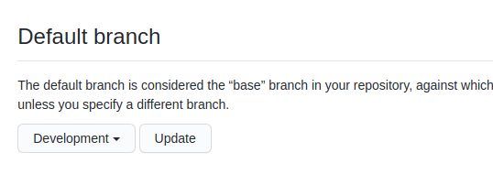

Finally, it only remains to set the Development branch by default